
Table of Contents
1. Welcome & Thank you
2. History
3. Race Goals & Principles
4. Parking, Shuttles, Camping
5. Aid Station Summary
6. Crew Team & Vehicle Summary
7. Drop Bags
8. Pacers
9. Race Results and Timing
10. Last Option for Food & Supplies
11. Dogs
12. Race Schedule
13. Medical, Withdrawals, & Cutoffs
14. General Advice
15. 100 Mile Course Descriptions & Aid Chart
1. Welcome & Thank You
Welcome to Pine, Arizona! We’re a small race, in a very small town, on a very tough course. We hope you enjoy your time in Arizona and have a great experience out in the mountains. When my brother Jeremy and I (Noah) started this race, we saw it as a great way to show people who aren’t from Arizona that there is more to this state then just hot, dry, desert. And boy will you see that in full effect on this course. There’s something pretty magical about the Mogollon Rim so thank you for choosing the Mogollon Monster for your weekend!
Thank you in advance to the families for supporting your runner through the training to get to this weekend, it’s a big undertaking not without its sacrifices so thank you!
2. History
  - “Mogollon Monster” is a two meaning term. On one hand the term refers to the sheer scale and difficult of 100 miles on the rugged and scenic Mogollon Rim while on the other hand the term references the mythical “Bigfoot” creature allegedly spotted in the area for as far back as 1903.
  - The Mogollon Rim, also locally referred to as “The Rim” is a 200 mile escarpment defining the southwestern edge of the Colorado Plateau rising from Yavapai County to the New Mexico Border. The name Mogollon comes from Don Juan Ignacio Flores Mogollón, the Spanish Governor of New Mexico from 1712 to 1715. The Rim ranges in elevation from around the 4,000-5,000 ft range in Payson, Arizona to around 8,200 feet on top of the Rim where the vegetation mimics many areas of the Rocky Mountains with Maple, Aspen, Oak and the largest Ponderosa Pine Forest in the World.
- 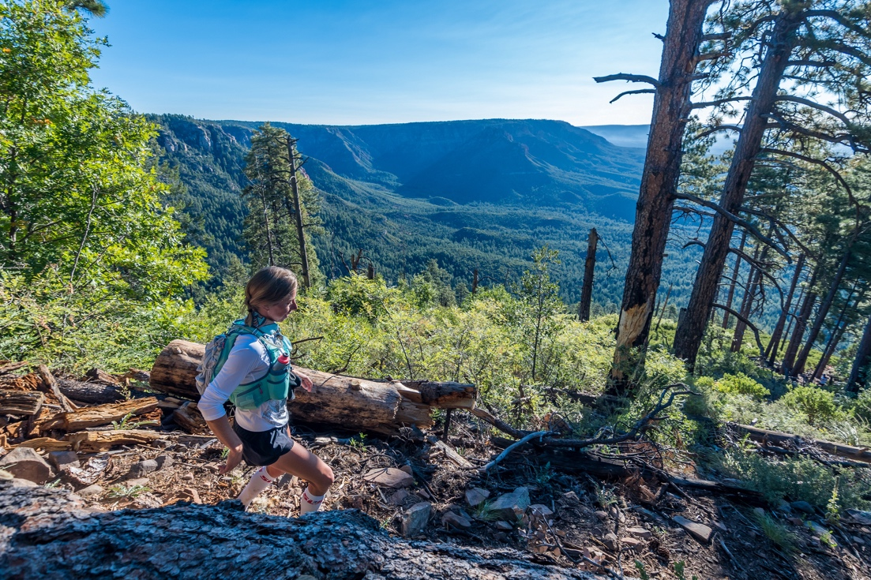
Photo: Andrew Pielage
Several of the trails used for the race hold historical significance in Arizona. The Highline Trail (#31) is used for about 20 miles in between the Rim climbs as well as the collection of trails that create the Cabin Loops are trails used in the Old West days to connect the cabins and frontier land along the Rim. The trails were the only access from the lower Rim and upper Rim where ranchers would graze their cattle in the spring and summer as snow melted. Forest Rangers and cattle ranchers’ alike still use these trails today for access through the forests and up and down the Rim. These trails will be the primary access points for the aid stations and the trail itself.
3. Race Guidelines & Principles
This race is hard. It’s rough. It’s rugged. It’s very rocky in places and very remote in others. Or both. I put all of that out there on the website from the start. Not to scare away anyone but to be very clear what people are getting themselves into. The trail ranges from double track smooth dirt to barely a single track overgrown by stiff, sharp manzanita and various cactus. You’ll be ducking, dodging, leaping and picking your way through terrain that has remained challenging for the last hundred plus years since the first settlers in the area broke ground on it. (Or “took over the land” may be a more appropriate description given it was all Tonto Apache land long before anyone else came…) Aside from some massive strides in trail sustainability achieved by the Highline Trail Initiative the last few years, very little has changed and you’ll be challenged by its unrelenting nature.
Having said that we are marking the course to give each of you the best chance in succeeding in this race by eliminating as much confusion in navigation as possible. This area has a fair number of trails and forest roads. Course markings will use orange ribbon with black polka dots for positive markings. The Cabin Loop will likely include pin flags with the Aravaipa Running logo on them as well. Wrong way trails and roads will be marked with a blue & white checkerboard ribbon. We have high intensity reflector tape for the areas that are covered at night in both white and yellow. This tape catches your headlamp and is very obvious which direction you go. There are also many of the trails which have additional reflectors put there by the forest service that will help light the way. The road sections will also be marked with “confidence markers” along the way to let you know you are on the right path. Nearly all sections of the course have their own fixed markers as recreational trails which can be used as helpful additions along the way. (example - Highline Trail #31 has many markers on trees, black diamonds with the name on it. Sections that are the Arizona trail are very well marked as well and Cabin Loop signs are sprinkled all throughout the Fred Haught, Barbershop, & Houston Bros trails).
With all the time and energy put into marking the course it is still the responsibility of the runner to know the course, the general turns and a working knowledge of at least where they are going, what color ribbons they are looking for and to pay attention to where they are going.
If you get off track, do NOT unload on a volunteer when you arrive at the next aid. It’s not their fault and they’re just trying to help.
Please refer to the race website course description and maps tab which details out each segment between aid stations. It’s very useful in helping to understand the course itself and what to expect from section to section.
Don’t litter. Ever. As any RD can attest, getting permits secured to put on a race in a National Forest, City Park, State Park...is extremely difficult, and in a lot of instances simply not possible. We have volunteers to help runners make it to the finish line. They are not there to pick up your trash. Course sweeps are not janitors. Be very aware of your gel wrappers, those tiny tops you tear off and any other refuse you may drop along your path, inadvertent as it may be. PLEASE pick it up and if you see something that may have accidentally fallen out of someone else’s...please pick it up and drop it off at the next aid station. There is NO excuse for littering and if someone in the race is reported to be littering with no regard for the area they are putting the race’s future in jeopardy and will be potentially disqualified from the race. Simply put... Don’t do it.
Weather is generally a predictable commodity in many parts of Arizona where the sun shines constantly. On the Mogollon Rim it acts more like a 12,000 ft. peak than an 8,000 ft. plateau. Weather comes from the south and hits the 2,000 ft escarpment and builds storms directly over the course. The average forecast for the middle weekend of September is 82 degrees and sunny with nighttime temps down to 42 and clear. That is for 5,300 feet at Pine, AZ where the finish line is. 2,000 feet+ higher where Buck Springs AS and Pinchot Cabin AS are it’s likely to be 10-15 degrees cooler putting a potential low around 30-35 degrees. This is what we saw in 2012 and 2013 races. A massive thunderstorm hit the race in 2014 and again in 2022 and 2024 where we had a cell that included some intense hail and lightning on top of the rim in the afternoon. Arizona is dry and brisk with very little humidity and the temperature drops the minute the sun drops. I strongly recommend a jacket in your pack or at the very least, your drop bag, where you plan to hit the nighttime miles.
While the forecast might call for clear skies that doesn’t mean a certain section of the course won’t get hit with a storm somewhere along the line. We’ve had runners get hammered with a lightning storm and hail at mile 85 on Milk Ranch Point. Sunny skies everywhere else.
There is of course the possibility of another major storm cell hitting the area like we saw happen in 2014 where we had to cut the race short at the halfway mark. Flash flooding is a major issue in the high country, just as it is in the desert. Much of the race, nearly all of the Highline Trail, runs through ravines that usually are small trickles of water. Please pause at these streams if you find them to be raging from a storm. If they are unpassable, wait a bit and the levels will decrease soon enough. Do not try to cross in a flash flood as it is not just water but includes debris and can knock you off your feet.
Lightning strikes in Arizona kill people every single year. In June 2015, a group of 7 people were hiking near Pinchot Cabin and a young woman was killed by lightning just standing by a tree. Just because we’re not at 14,000 feet and in Colorado doesn’t mean you can’t die. The weather can hit extremely fast, and when it does during monsoon season, it hits very hard. The ground doesn’t have the vegetation to sustain heavy rains and flooding occurs quickly. In 2017, the Highline Fire caused damage to the area east of Washington Park and within two months of that, massive flooding completely washed out sections of the trail causing the forest service to enact a full closure, rerouting our race and the ensuing 2018 and 2019, Zane Grey 50 miler.
We will make the decision for the best interest of ALL the runners and volunteers should we have another major storm put the lives of the runners in jeopardy.
While I can appreciate how much training, effort, money and time you have all spent on getting to this race, in the best shape possible, the lives of the volunteers, crews, and runners are far more important than a buckle ever will be. I hope you all agree and let’s hope for weather much more like our other race years.
This graphic is helpful as well. If you are caught in a lightning storm with a group of other runners, make sure you spread out 100 feet from each other. Do NOT crouch near each other as the electricity can travel between each of you.
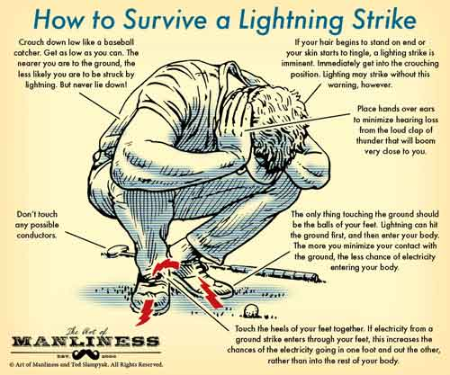
Some of you will feel the heat a bit more than others depending on what you are used to from where you travel in from. While a high of 85 it may not seem like much but Saturday and Sunday most of you will hit those temperatures along the Highline Trail at 5,300-6,600 feet. Much of that exposed running on sandstone red rocks or just in and out of the trees. The higher elevation takes a bigger toll on you than maybe you think and with the dry air, water consumption becomes a key component of your potential success. We will stock aid stations with plenty of water and ice but don’t leave an aid station during the day without plenty of water. Especially Fish Hatchery to Myrtle (26-39 ish) if you hit it mid day Saturday. That’s a tough stretch that offers very little shade and a fair amount of climbing. Extraction is difficult at best here if you get in trouble- we know, someone tried to run it with a single handheld and no shirt and couldn’t continue up Myrtle.
ALWAYS check in and out with the aid station volunteers or HAM Radio team so we can track your progress and ultimately know the last place you were should you be delayed in reaching the next aid station. Do this yourself and make sure your bib number is always visible, on the front of your body. This is VERY important so please make a conscious effort to make sure we didn’t miss you coming in or out. Don’t leave without them checking you back out.
And if you withdraw, it is imperative you inform the radio team, aid station staff, or race director. Otherwise we will assume you’re still working the course.
We want you to be successful in running that last mile through Pine, rounding the turn at Randall Street and pulling into the comfy confines of the finish line and the belt buckle that is waiting for you.
With any Ultra adventure it’s not always predictable what will happen for you out there so should you decide to drop out of the race you MUST tell the aid station captain and/or race director.
We have to keep accurate count of all the runners and if you drop without telling anyone we will be expecting you at the next station and when you don’t show up, we’ll be forced to send help. Please help us avoid those situations by alerting the aid station captain if you come to that decision.
Animals on the Course - This course is at times has seemed like a zoo when out on training runs. The trail is covered with animal tracks, bear scat, elk tracks and the forest is no different. People come from all over the country to hunt elk in the Payson/Pine area and you’ll likely see why and I can almost guarantee your crew will when they come across herds of them driving from one aid station to the next. There ARE rattlesnakes, bull elk, open range cattle, black bear, and mountain lion on this course. Not one of these things would be a desirable encounter in the middle of a hundred mile run but at the same time none are a particular danger to anyone. I’ve ran hundreds of miles of this course since 2012 and have seen four or five rattlesnakes, one bear and zero mountain lion out there. Plenty of elk and on certain sections you might be startled by an Angus or Hereford but often they just dart off into the trees. If you do come across a rattlesnake just back off it and go around it. They do not want to be bothered any more than you wanted your heart rate to spike like it just did. Several people have spotted a black bear on the course in recent years and every time they ran off as soon as they spotted a human. Mountain lions have been spotted and likely you will never see one. This is not to scare anyone but it’s important to know what is out there should you come across it. You can do your own research in how to handle an encounter with any of these animals on the trail but generally, not backing down will work for most (without Grizzlies in Arizona) and making noise and appearing larger will scare them off. Chances are much higher you will not see anything but an elk and cow. There is also a small chance of a mythical Bigfoot creature. You may have heard of him...The Mogollon Monster.
This seems like just a catchy name for a race but this “thing” has indeed been reported by a good deal of local residents and in the 2012 taping of “Finding Bigfoot” in Oxford, AZ (outside of Payson) they had over a hundred residents show up talking about their stories of camping on the Rim and seeing inexplicable things in the trees. While I can’t quite come to grips with fully believing this myself I did stay at a B&B in Payson where after mentioning this race I’m directing, the owner started telling me a story of camping near Knoll Lake (2 miles north of Babe Haught Trail) he and his son saw something standing over 8’ tall next to the tree 20 feet away. It wasn’t quite dusk and you could see he was visibly weirded out just repeating the story. He didn’t strike me as a man that makes these kinds of things up. So...I don’t know but keep that headlamp on. :)
Please be polite to all trail users and the volunteers. There likely will be other hikers out on the course while we are there and please be polite to them all. I doubt anyone would be otherwise but specifically with volunteers it is difficult to find the great people we have for such a long time commitment away from home. They are a huge asset to the success of this race and we’d be nowhere without them. While the volunteers will do their best to point you in the right direction, it is YOUR responsibility to know your course. Please thank them for their time and helping us all out in making this race successful and to the finish line.
For this race, cutting switchbacks is not an acceptable means of travel. All runners are required to follow the marked course and the course description of the race. There are several areas where a shorter route is possible albeit with more vertical. You must take the marked trails with the orange & black ribbon used by race officials. Continued abuse of this will potentially result in time penalties or disqualification from the race. If you find that you’ve gone off course, you need to return to the point where you left the course, and then continue forward. We know, it’s annoying and stressful. But, it’s fair to your fellow competitors.
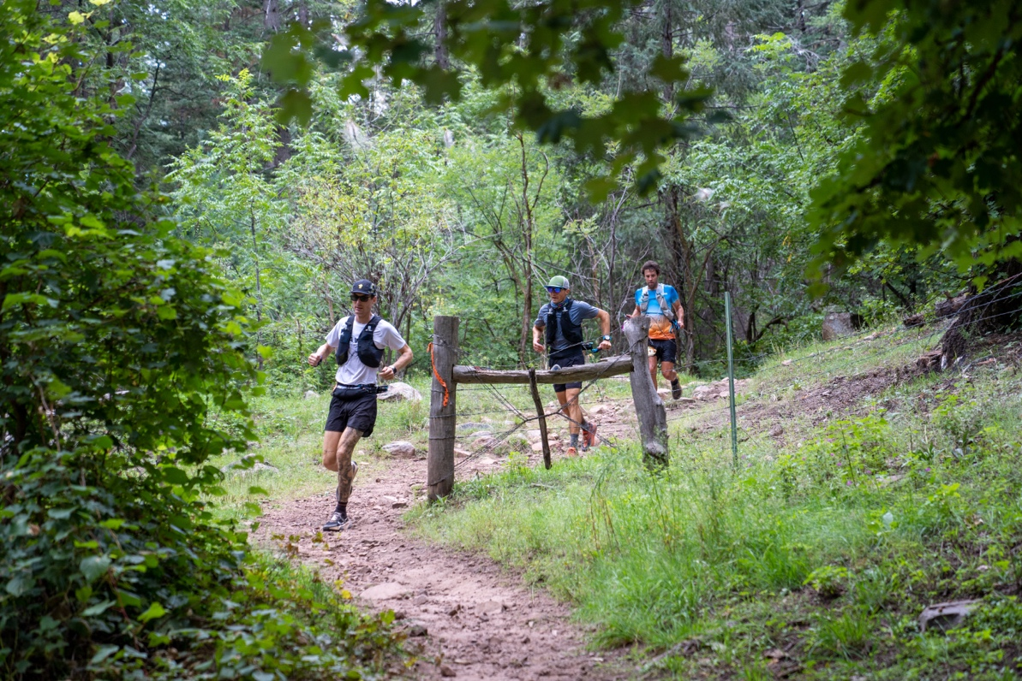
4. Parking, Shuttles, & Camping
Runners are not allowed to park at the Pine Trailhead or Trailhead Two-Sixty for the race. We have a parking area at the Old Pine Parking lot which is a 1-mile drive to the Pine Trailhead, or you can get dropped off on race morning. You may camp at the Old Pine Area as well. No permit is needed to camp as it is National Forest land so you will just find a spot in the area and post up. Your vehicle can remain here all weekend.
100M Start Line (Two-Sixty Trailhead): You may get dropped off by friends or family but they are not allowed to park and hang out for the race start, even if it’s “only for a minute or two.” This parking lot is very small and not easy to maneuver for the buses coming in, unfortunately. Buses will arrive around 5:20-5:35am so please try to straddle those arrival times to make it easier for the buses. You’ll understand when you see the lot.
You will bring your drop bags to the start line and you may also grab your bib at the start line race morning. We will have a jug of water and coffee and some breakfast snacks at the start.
Shuttle: Parking for all race starts will be at the Old Pine Parking Area which is one mile south of the Pine Trailhead. The shuttle from the Old Pine Parking lot to Trailhead 260 (100 mile start line) is about 45 minutes. We will have the shuttles leave around 4:25am and 4:40am for the 100 milers.
100 Milers: You may be dropped off at Two-Sixty trailhead in the morning but there will be no parking in the main (start line) lot so it would be a drop off/drive thru only situation. We need to leave plenty of room for the buses to be able to maneuver within this lot and drop off the rest of the runners.
42KM: Your starting point will still be the Pine Trailhead but you will park in this same Old Pine Parking Lot. There will be a shuttle transporting runners from the parking to the start line from 6:15-6:50am, continuously. If you walk from the Old Pine Parking area, it is about .65 miles or 1Km. NO Parking allowed at the Pine Trailhead. Friends/family can hop on the bus to watch you begin and get a ride back at 7am just after the start.
Finish Line Shuttle: As you will be parking ~2 miles from the finish, we will have our staff shuttle to bring runners back to their vehicle periodically.

5. Aid Stations & Supplies
There are 10 total aid stations not counting the start and finish lines. Aid stations every 4.0 to 12.1 miles including water, ice, electrolyte drink (gnarly Fuel 2O), sweet snacks, salty snacks, and fruit. Please plan to run with at least two bottles of water. As the miles increase, our aid stations will include more substantial food such as grilled cheese, quesadillas, ramen, broth and/or soup.
Our aid station staff – Hanna, Pati, Jen, and Catherine - take a great deal of care and planning when preparing for your 100-mile race and all of them will be on course, manning at least one aid station. We have other volunteers that have been at every single Mogollon Monster since 2012 (Linda Van at Pinchot Aid – plus her A+ team with Paul Bonnett, Tim Hackett, Kiely & others) and many others that are veteran trail runners who have an invested interest in assisting you in continuing your race. You’ll see a lively group at Buck Springs John Bawden & the R.O.T.R. crew are back. The Beaty brothers, Chris Thornley & Squirrels Nut Butter, Kim & Elliott Ulrich, and many many others have volunteered more aid station hours with Aravaipa than we can count.
You may arrive worn and bruised but you’re here at least. Rest, eat, and drink. Laugh a little bit. Continue on when you’re ready. It doesn’t always get worse.
NOTE: We have had runners leaving Fish Hatchery (now mile 26) woefully underprepared for the hot, exposed section and paid the price. One handheld will not be enough. Even two would be pushing it. This section is now hit earlier in the day so more of you will have to run it in the middle of the afternoon. Still, in other years runners have been greeted by intense rain and hail near Hatchery.
Either way, more of you will get to experience Myrtle at sunset and that’s pretty special.
Do not underestimate ANY of the sections on this course, especially those on the bottom of the Rim.
Some general items typically found at Aravaipa aid stations (not always guaranteed). If you don’t see something, please ask in case we have it.
- Oreos
- chips
- trail mix
- potatoes (and salt)
- bananas
- watermelon
- oranges
- pickles / pickle juice
- dates
- fruit snacks
- candied ginger
- bean rollups
- peanut butter and jelly sandwiches
- Coca Cola
- Mountain Dew
- Ginger Ale
- sunscreen
- Squirrels Nut Butter/ Vaseline
- tampons
- Basic first aid kit
- Hot water options: broth (chicken & vegan), hot chocolate, coffee, tea & ramen.

Additional food items for 100 Milers (subject to change):
Horton Trailhead: meat & cheese rollups and hummus & avocado wraps
Fish Hatchery: chicken salad and chickpea salad sandwiches
Myrtle: Rollups – meat & cheese, hummus & avocado, hot water options
Buck Springs: chili with rice (meat & vegan meat), hot water options
Pinchot Cabin: mashed potatoes, hot water options
Washington Park: Pasta & red sauce (meat & vegan meat), hot water options
Geronimo Aid: Pulled pork with BBQ sauce & vegan red lentil red lentil sloppy joes, hot water options
Donahue Aid: potato soup, pinwheels, pancakes (100 Mile Runners), hot water options
Pine Canyon Aid: Sandwiches- turkey & cheese or hummus & avocado; hot water options
Finish Line: Pancakes (early morning) and hot dogs
There are several sections between aid stations that are fairly long at around 12 miles. These sections are important to note and prepare yourself with proper hydration.
Blister control (see: Duct tape), Vaseline, Squirrel’s Nut Butter and general first aid supplies will also be at most aid stations. If you have challenges with your feet we will do our best to help with supplies at hand but please plan ahead in the event you need something specific. Please bring it with you or ask for medical assistance to see if our team can fix it. Sections of this trail can be dusty so having a change of socks can feel like a million bucks in the middle of your race.
We will also have salt caps (GU electrolyte caps) available at nearly all the aid stations as well as candied ginger to help with stomach issues.
We do not guarantee any gels on course so if you require those, please bring them yourselves.
I know there are a growing number of gluten allergies out there and vegan runners with special diets. I suggest if you have a dietary restriction, you plan accordingly with your drop bags for food that works for you. Hanna & Pati are always trying to provide options to accommodate but please take on that responsibility yourself if it is important to your success.
If you are crewing and waiting for your runner and want to help out at the aid station while you wait you are welcome to unless it’s clear we are fully staffed and don’t need assistance. But given the length of time the volunteers are dedicating they probably would greatly appreciate a chance to sit down and maybe take a quick nap.

6. Crew Access
42KM: There are no crews allowed on course for the 42Km distance.
100 Milers: Please follow the link below to the Crew Guide for all details regarding rules, locations, and driving directions.
The most important thing with crewing on top of the Rim is that your vehicle never impedes the flow of traffic.
If you cannot safely park in an area, please continue on or wait until a spot opens up. Our permitting agencies make this a huge sticking point each year and emergency vehicles (think, Firetrucks) need to be able to drive on all of these roads at all times (yes, even if you’re only going to be there for five minutes).
The second most important thing with crewing is if your runner decides to drop from the race, they absolutely, 100%, need to go to an aid station to report to race officials that they are no longer running in the race. THIS IS CRITICAL. You can always shoot the RD a text with this info too.
MedStar Solutions 24 Hr Emergency Number (also printed on runner bibs): 480-269-4126
Race Director, Noah Dougherty: 480-518-6731

FULL RUNNER CREW GUIDE HERE
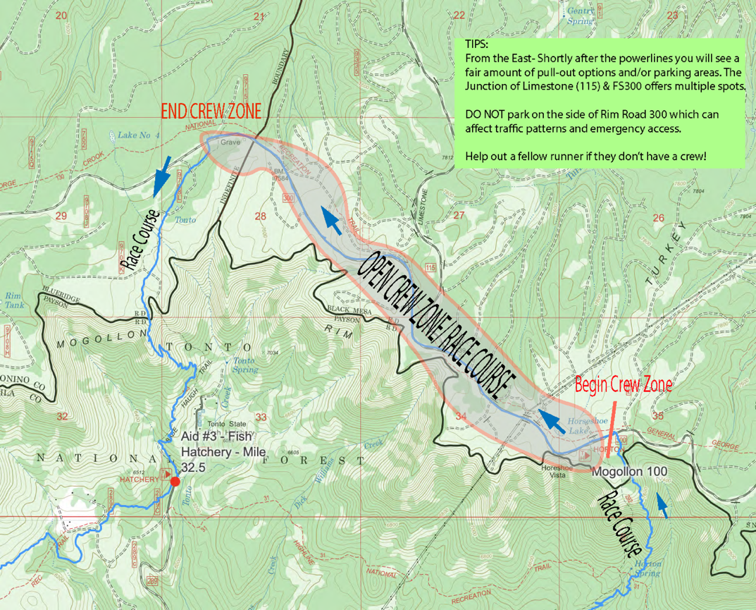
7. Drop Bags
Drop bags are allowed at Fish Hatchery, Buck Springs, Geronimo & the Finish Line. Drop bags MUST be kept to a manageable (Small) size and clearly mark your bib number, name and the station’s name on each bag so we can easily get it out for you when you come through. As our good friend, Scout, used to say: “it’s not a vacation, it’s a race.”
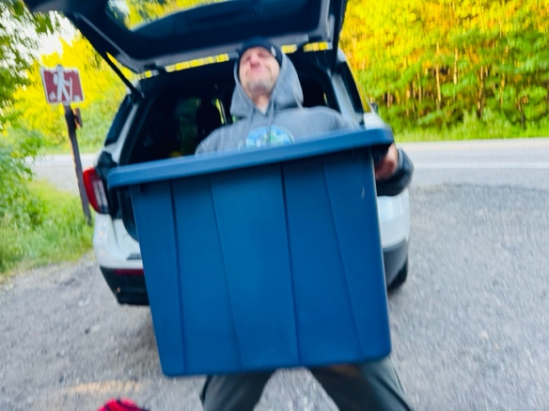
:real “drop bag” from a race – don’t do this:
After the race and after each aid station is closed down, we will return them all to the finish line. If you are finished with your drop bag, please place it in the “used drop bag” location- this may expedite its return to the finish area.
Once the race ends and we have packed up, we will have your drop bags at our Phoenix warehouse available to be picked up or shipped to you (at your cost). We keep the drop bags for 30 days and then toss or donate the items.
Drop bags can be dropped off starting at 5:00AM on Saturday at the start line. We will have each drop area labeled, just drop them in their respective areas and we’ll do the rest. It is your responsibility to make sure you drop the bag in the correct space for the aid station.
8. Pacers
Beginning at Buck Springs Aid (mile 43), pacers are allowed to join you. One pacer at a time, no muling, and all pacers are responsible for their own transportation. Please make sure your pacer is aware of the terrain and difficulty of their section to help mitigate the risk of another runner being on course and running into trouble. For most, they’ll be joining at night – headlamps, warm clothing, etc.
Pacers will not need a bib but should notify the aid station when you head out with a runner so we can make note of it.
Other locations where pacers may begin (or end) with you: General Springs Crew Zone, Dickerson Flat Crew Zone, and the Pine Trailhead.
At this time, we’re not able to have pacers switch in and out on the bottom of the rim aids.
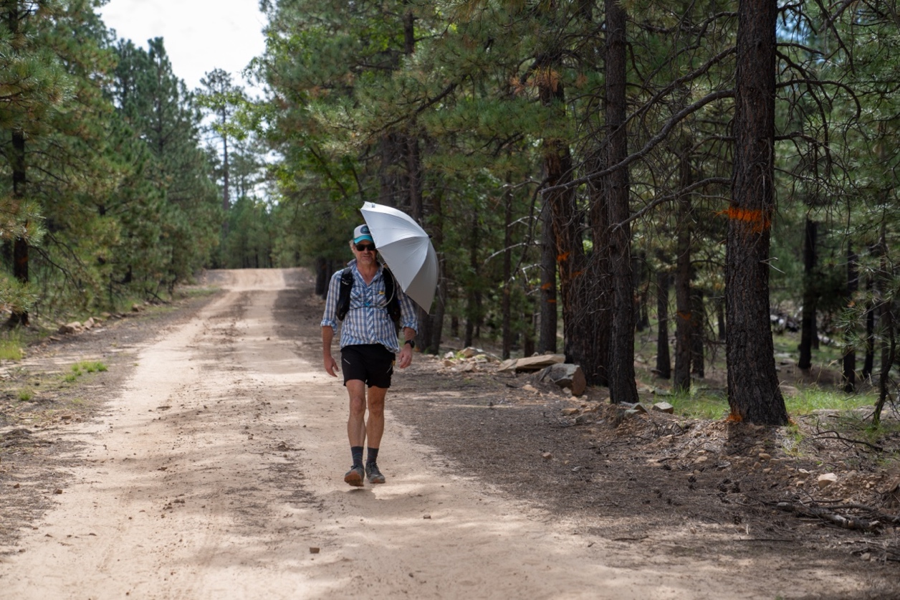
“Finishing isn’t just something you do. It’s something you decide.”
9. Race Timing & Results
We will be utilizing a chip timing system at this event to record your time at the finish. You will be provided with a timing chip attached to the back side of your race bib. It is important to not crease or fold the timing chip to ensure your finish time is read. We will also have a limited number of remote timing points on course that should allow crews and family to better track your progress during the race.
Visit www.live.aravaiparunning.com to follow along. NOTE: This course does not have good cell service and it is quite possible that the online timing points will not post immediately or at all during the race. Thank you for your patience.
Following the race, we will post official results on Ultrasignup as well as on the live.aravaiparunning.com link which will contain aid station splits (as available).
10. Last Options for Food & Supplies
Pine, AZ is a small town with just a few local restaurants and shops. They do have a small grocery store called the Ponderosa Market with most everything you need but no sports/endurance stores. There a couple gas stations in town including the Chevron on the northern end of town where they also sell pizza and other hot to-go items as well as a fair amount of camping equipment.
If you need any running gear last minute, your best bet is in Phoenix. Otherwise, there is a Walmart in Payson if you need more camping type supplies. If you are flying into Phoenix for the race there are a few ultrarunning stores called Sole Sports. www.solesportsrunning.com You can hit that up before heading up north if needed. They have anything ultrarunning related you may have forgotten.
There are several options for restaurants in Payson and a few in Pine:
Payson is larger and offers most fast-food options and some other dining options as well as hotels/motels, grocery stores, and gas stations. This is around 20 minutes from Pine.
Star Valley is a few miles east of Payson and also has a gas station right off the AZ260.
There is also a small general store in Forest Lakes & Rim Resort gas and supplies which are on the far eastern end of the Rim Road off of AZ260. You could hit one of these before going on the Rim Road towards crewing zones. It is near the Forest Lakes Lodge and includes two gas pumps, although their hours are limited.
Town of Pine Dining:
THAT Brewery is on the 87 right in Pine. They have beer and a full menu with proceeds going to the Arizona Trail and other local organizations. www.thatbrewery.com
The Old County Inn is seemingly “the spot” in Pine and we’ll be returning this year tfor packet pickup. It has a good patio, wood fired pizza, live music and solid beer options. http://www.oldcountyinn.com/
The Pinewood Tavern, located right next door to the town grocery market, is also owned by the same family as Old County Inn and offers a full bar and food menu.
Mike has also added a third restaurant to the mix with a wine & bottle shop just off the main drag called Pine Provisions.
For coffee and breakfast while your runner is off in the mountains running a ridiculous amount of miles in one go, they have Early Bird Cafe for traditional diner food that’s right next on the main road (and race course) in town. There’s also a great little fudge, ice cream and espresso shop just north of the Old County Inn on the opposite side of the road called the Pine Creek Fudge & Espresso.
Closer to the 100 mile start line, Christopher Creek offers a couple dining options including the Landmark at the Creek with a great patio area and the Creekside Tavern.

11. Dogs
I love dog’s. I run with my dog. You can bring your dog. It just has to be on a leash. Not my rule but one we need to follow. You can NOT run the race with your dog. And please keep dogs outside of the actual aid station if volunteering.
12. Race Schedule
Friday September 5th, 2025 4:00pm-7:00pm Registration
Old County Inn - http://www.oldcountyinn.com/
We will meet at this local spot in Pine (where the actual race course runs right behind), starting at 4pm. You can ask any course questions and pick up your race bibs and bag. They serve some great local brews and have a full menu of wood fired pizzas and such if you want to grab something to eat.
Saturday September 6th, 2025 – 5:15am Race Setup & Registration
We’re setting up at 430am at the starting line and anyone that didn’t catch registration that evening prior can check in and pick up at 5:15am.
YOU MUST CHECK IN ON SATURDAY EVEN IF YOU CHECKED IN ON FRIDAY.
Saturday September 6th, 2025 - 5:00am Drop Bag Dropoff
All drop bags must be dropped off by 6:10 AM to be delivered to aid stations.
You can start dropping off your drop bags starting at 5:00am at the race starting line. We will have the supplies for each aid station laid out with signs and you will see a sign for each aid station drop bag. Place them here and we will get them to the station as soon as the gun goes off. (I don’t really have a gun...)
Saturday September 6th, 2025 - 5:50 am MANDATORY briefing
This is my only chance to have everyone together and pretending to pay attention to me as they nervously twitch and wonder what that strange ache is in their left knee that wasn’t there two hours ago. It takes a lot to put these things on as many of you know and I’d like to thank a few great volunteers that helped make this happen, put out some information on the course and help with crews getting in last minute questions. Plan on no more than 5 minutes and you’ll be back to the bathrooms and on your own until 5:55am when we’ll play the National Anthem.
***Regardless if you came in Friday night and registered you STILL need to check in Saturday morning so we know you are at the start and we know to track you into the first aid station. If for some reason you decide not to start PLEASE inform me ahead of time so we can alert everyone not to expect you later on.***
Saturday September 6th, 2025 – 6:00AM START
Sunday September 7th, 2025 - 8:00pm - COURSE CLOSES (38 Hour Cutoff)
13. Medical & Cutoffs
We will have MedStar Solutions medical staff scattered throughout the course, following along with the pack on a roaming basis and posting up at busy aid stations – if you need assistance, please ask! While our medical team is there to HELP YOU and do what they can to keep you moving on the course, we reserve the right to pull you from the race if medical officials deem it necessary. Please understand that these decisions are made for your safety and do not argue. With the remote nature of much of this course, continuing on in a state where you cannot safely navigate is a recipe for disaster and we are here to prevent that.
NOTE: If something happens to you or another runner, do NOT call 911 right away (unless it’s an obvious danger medical concern). Our medical team is highly trained in these scenarios, has been with us at this race the last five years and understands the terrain and driving access points. Please call their 24-hour number that will be answered by a real human being, and they will dispatch accordingly. All 100-mile runners will have this number printed on their bib.
MedStar Solutions: 480-269-4126
Cutoffs are posted for major checkpoints and will be strictly enforced by the aid station captains. The cutoffs are based on an overall 22:22 minute mile pace (averaged over the entire mileage, it varies section to section.) While this course is very rough and tough, I feel this is a fair cutoff given the elevation gain, altitude, terrain and additional miles. These cutoff times are for when you need to be leaving the aid station. You are required to finish the race within this time frame and within the established cutoffs. Should you fail to reach one of the checkpoints the aid station captain will ask you to please stop and will inform you that your race is unfortunately over.
Please do not argue, this is for the safety & logistics of everyone out there.
Drops/ Withdrawing from the Race
Don’t drop. Seriously, you’re stronger than you give yourself credit for and you can keep going. However, we also understand that things happen that say otherwise. You MUST inform an aid station captain before leaving the course so that we are not waiting for you to arrive at the next aid station (did you notice this is at least the third time this has been mentioned so far?).
Further, given the remoteness of this course, if you find yourself in a position where you want to quit at on top of the Rim, this is your warning that it could take upwards an hour to retrieve you plus at least that amount of time to return to the finish line. Take a few minutes to gather yourself. Try to eat and drink something and reconsider. Keep Going.
14. General Advice
You can use trekking poles if you want. You do not have to carry them with you the entire time if you wanted to leave them at an aid station or grab them later on from a drop bag. You have four rim climbs in the first 40 miles and you’ll see that Turkey Springs around mile 85 is also a tough climb. You’ll likely arrive at Myrtle or Buck Springs and feel rougher than you’d like. Gather yourself and enjoy the smoother single track in the pines for the next 18 miles. It doesn’t always get worse.
Gaiters are useful if you’re one to wear them.
Run the roads if you can. They are never more than 4.5 miles long but a welcome break from the trails and an opportunity to make up some time.
Take some pictures, take a look around. This is a beautiful course, diverse in nature and scenery and at so many turns changes the look and can take your breath away.
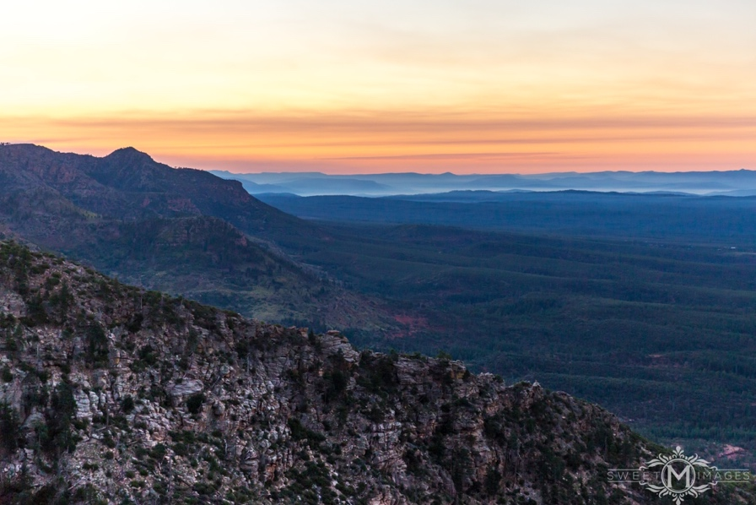
Photo: Melissa Ruse
Please don’t be annoyed if aid station volunteers are overly caffeinated and having more fun than you at that particular moment or if you hear music blasting through the woods from a mile before you get there. We can’t help it.
Also, on that, do not rely on the volunteers, the photographer, or medical personnel to know everything about your race course. That is your responsibility. They will of course be as helpful as possible but I do not want to hear that “a volunteer told me to go the wrong way” on race day.
Arizona is dry. This is important because your water consumption may be more than expected. Even at the higher altitudes on the Cabin Loop trails it’ll be cooler but your body needs more water. Those not used to the higher altitudes may need more water than those not acclimated. It’ll be cooler up there but you still need to be drinking water.
Don’t let a 78-86 degree forecast fool you. Don’t underestimate the seemingly moderate temperatures. It feels much hotter out on the Highline Trail so plan ahead, leave aid stations with enough water and stay hydrated. One handheld will not be enough out there.
While most sections probably are best run with a pack due to the longer nature between aid stations the Cabin Loops are very runnable and if you are so inclined they would be great sections to run with a couple bottles (not one bottle).
Do not forget to have a headlamp/flashlight in your drop bag there as many of you will be arriving at Fish Hatchery in the afternoon and may not make it to Buck Springs before sundown. If there’s one place on course you don’t want to be without a light, it’s Myrtle. You don’t want to be in the dark on these trails. Something will eat you.
We HIGHLY suggest having the 100-mile track on your phone or gps watch for a piece of mind and reference point on course. If you think you are off the trail don’t wander too far off and don’t panic. Backtrack to where you think you were last on the trail and look around. If you are in an area where you can see from a ridge you probably can spot another runner nearby. Even with good markings runners get off course every race. The key is to manage the situation yourself and recover. Stop, think about your situation and find your way back on the trail. If you are gone an unreasonably long time we will send Search & Rescue but many times a runner can recover themselves if they remain calm and patient in the situation. If you are hurt and cannot go on do NOT try and take a “shortcut” back to the aid station. This decision is what gets people in a serious predicament. Stay on the TRAIL so we can easily find you and get you back to medical attention.
If you go off the trail to use mother nature please leave something on the trail of yours like your headlamp, hat, pack or something else of value you won’t forget. This is extremely important if you are in the back of the pack and pushing the cutoffs. Our sweepers are behind you but could pass right by you in the woods and think they are behind the last runner. Yet you’d be using the little boys room in the trees and in fact were behind us. You can see how this could create a challenge in tracking someone. So just leave something for the sweeps to notice and they’ll wait for you so we keep it all in line.

Remember, you paid to do this. You trained for it. You read all the comments of how rough, rocky, tough, challenging, difficult, etc. this race has been described to be. You’ve seen the videos we’ve posted. The pictures everyone has taken. The race reports posted. You know what you’re getting into. So embrace it. Enjoy it. Take the good moments, wrap them around the bad and take another step forward. Climb that hill, stay on your feet.
And when all else fails, remember...
“You’re only tired because you think you are tired. Keep Going!”
----------------------------------------------------------------------------------------------------------------------------------------------
15. Course Descriptions – (pulled directly from the website)
Aid Station & Cut-off Info for 100 Mile Race
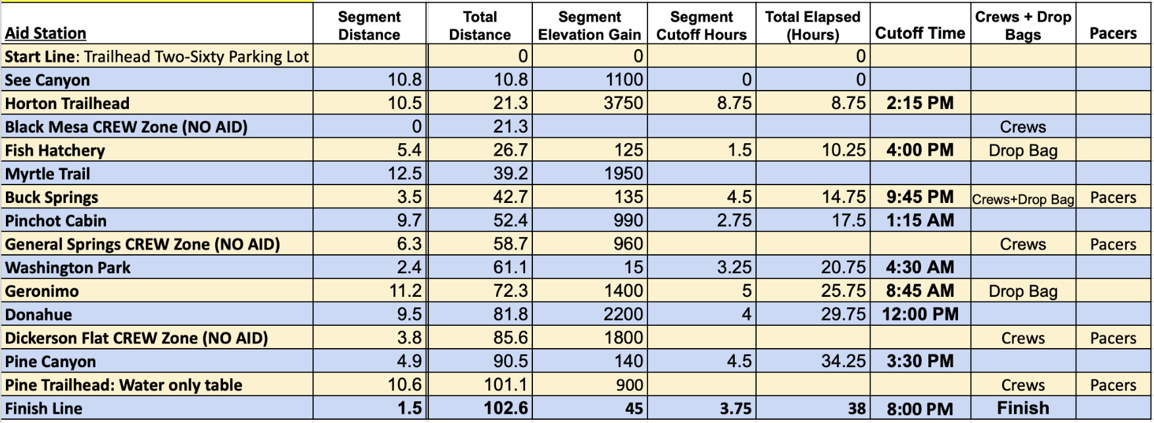
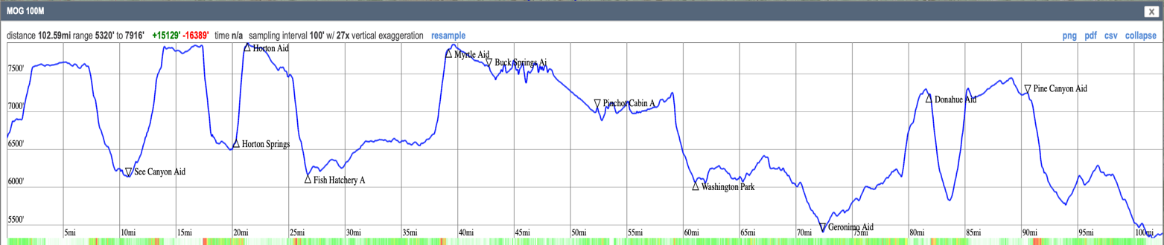

--------------------------------------------------------------------------------------------------------------------------
#1. Start to See Canyon Aid Station ~ (Mile 11.1) - 11.1 Mile Segment, ~1,100 feet of Gain
Our start was the finish of the Zane Grey 50 Miler for a couple of decades. You'll begin your 100-mile journey here and immediately turn right off the Highline Trail to climb up the Mogollon Rim, gaining just over 1,000 feet in a little more than two miles. This will likely be your easiest and shortest climb to the top and the views are stunning so soak it in. You'll cross the FS 300/ Rim Road, following the historic General Crook Trail before heading down Drew Trail #291 to the See Canyon Aid Station. There is a short out and back here to reach the aid station parking lot.
#2. See Canyon Aid to Horton Trailhead Aid Station ~ (Mile 21.5) – 10.4 Mile Segment ~ 3,750 feet of Gain
Leaving the aid station, you'll head back the same way you came but continue up the Rim on See Canyon Trail, climbing some 1,700 feet as you cap out at the Rim Road once again. This time you'll essentially continue down an old forest road through the trees and quickly descend off the Rim once again, this time following the Promontory Butte Trail #278 down to the Historic Highline Trail. When you reach the butte (look up and enjoy this view), the initial descent off the rim is quite steep with loose ground as you make your way down and around the edge of the rim. There was a wildfire that blew straight through this area (and Horton) in the last year which then coincided with deadfall, rock slides and burnout. And although we have completed enough trail work this summer to agree this is the best we've seen Promontory ever look, you'll likely still be cursing our name. Enjoy the process.
Now, once you reach the Highline you'll head West (turn right) and follow this gorgeous section of the Highline to the Horton Spring, a natural spring you can see the source as it flows from the rocky mountainside. There is a decent amount of climbing mixed in this section but also more forest to help with providing shade. This is a beautiful area and worth taking a minute at since you'll begin a steep climb immediately after. Following the small single track up the left side of the waterfall area, you'll continue climbing on short switchbacks up to the top of the rim. This section of the course is one less traveled and the connector from the Highline to above the Springs can be difficult to see so just make sure you're keeping an eye out for the orange pin flags and our orange and black polka-dot ribbons. This time, you'll *carefully* cross the Rim Road to the Horton Trailhead Aid Station.
#3. Horton Trailhead to Fish Hatchery AS (Mile 27) - 5.4 Mile Segment ~ 125 feet of Gain
You are now around 7,900 feet at the top, having climbed around 3,700 feet on the previous section. Use this section to catch your breath and enjoy some easier miles to make up some time or just prepare for the upcoming miles with friends. Follow the Rim Road for about 3 miles before turning left onto the Babe Haught Trail #143. This section of road is what we're calling the Black Mesa Crew Zone where your crews are able to see you on your way through. NO crews allowed AT the Horton aid station. Continue just beyond the aid where the crew zone begins.
Once you hit Babe Haught, you'll kind of meander through the forest before you begin to descend of the rim where you'll enjoy some incredible views looking south. You'll be able to see East along the rim as well including the Myrtle Trail where you'll be heading in the near future.
NOTE: Fish Hatchery is your first drop bag location and some (most?) of you will need to make sure you have your headlamp (and possibly even warm clothes?) as your next drop bag location is Buck Springs at mile 43.
2nd NOTE: In the four years we've run this course, we've had two years with quite the monsoon blowing in - hail, lightning, absolute downpours and subsequent flooding of small streams. In 2024 we probably had 25 runners camped out in the aid station around 2pm, just waiting for a reprieve. Consider having a rain shell on you the entire time. And on the other side of this, without a monsoon, it can get HOT and you will be exposed for many miles leading to Myrtle. Please come prepared.
#4 Fish Hatchery to Myrtle AS (Mile 39.2) – 12.4 Mile Segment ~2,950 feet of Gain
By now you're probably starting to understand what we mean when we say the course beats you up. Nevertheless, you're going to now experience the Highline Trail for the next 10+ miles through thick manzanita bushes, exposed climbs, high grasses, ferns up to your chest, and rocks. Lots. of. rocks. What used to be a little under 10 miles in total and rough going to the aid, we are now pushing 12 miles after the Highline Restoration Initiative completed their trail work this year. As a result, your section is longer but easier to navigate, smoother in terrain, and actually includes a bit less climbing on the way to Myrtle. The turnoff from the Highline to Myrtle Trail is hardly noticeable as I'm fairly certain this trail is used 2-3 times a year at most. You'll make your way up a small hill and where the Highline drops down into a tall grassy area that previous Mogollon runners cringe at the thought of, you'll head right/north up the Myrtle Trail to the top. The first part of this trail is difficult to follow, even with our trail work to try and make the trail noticeable. Once you're on the switchbacks and climbing up the Rim, you'll be treated to waist high (at least) grass covering the trail as you wind up to the top of the rim, completing your fourth rim climb in just about 39 miles.
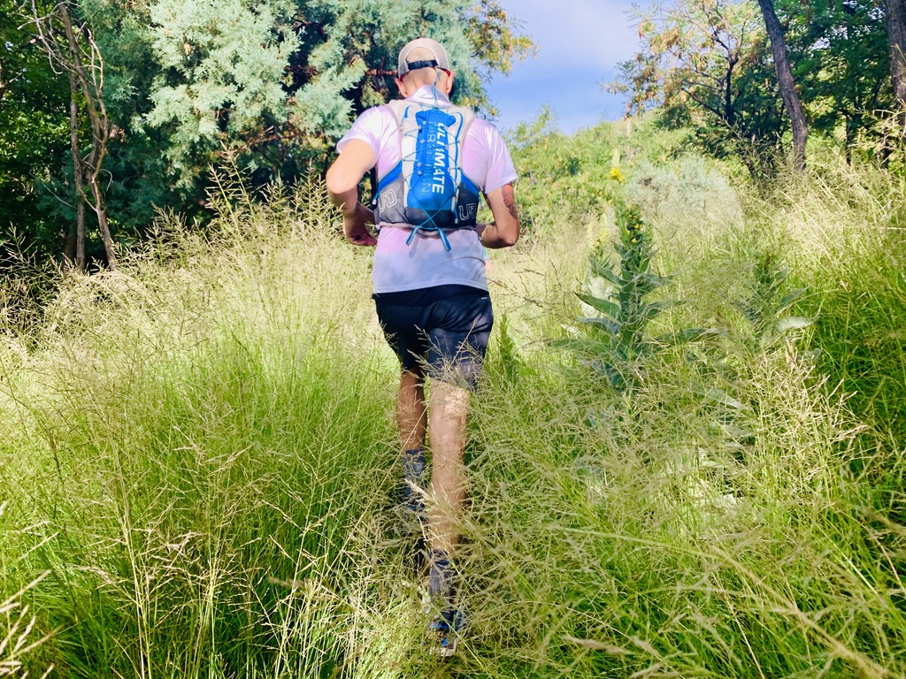
#5 Myrtle Aid to Buck Springs AS (Mile 42.8) – 3.9 Mile Segment
Myrtle will be a smaller aid station as you'll head turn left onto the Rim Road and continue just under 1/2 mile where you'll turn right onto FS321 on your way another 3.5 miles to Buck Springs. This entire section is on forest service road and a good opportunity to get yourself together and chip away at some "easy" miles. You'll be spending the next 20+ miles on top of the rim with easier terrain (comparatively), around 7,500-8,000 in elevation, and likely into the night for most of you. Buck Springs will have crew access and your first opportunity for a pacer.
#6 - Buck Springs to Pinchot Cabin AS (Mile 52.4) – 9.7 Mile Segment
Now over 42 miles into the race, you can pick up a pacer before heading out towards Pinchot Cabin. This is known as the Cabin Loop, a series of trails in the Coconino National Forest that certainly don't scream "Arizona" but is a pretty amazing reprieve for us Phoenicians in the hot summer. Leaving the lively atmosphere of Buck Springs, you dive into the forest and continue west on the Barbershop Trail, named after a local sheepherder who was quite good at sheering his animals. While you are technically dropping in elevation from Buck Springs to Pinchot, it might not always feel that way with a number of small canyons on your way. Connecting with the Houston Brothers Trail, once a major portion of the original 100 mile route, you'll head straight north of some incredible single track, descending to the actual Pinchot Cabin set in a little meadow. Turn left at the entrance to the meadow and the aid station will be another 1/3 of a mile up on top of the hill, passing a small metal cattle gate that looks like it was destroyed in Jurassic Park.
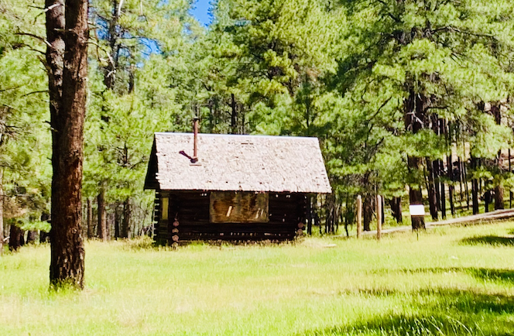
Pinchot Cabin in the meadow, 1/3 mile from Pinchot Aid Station
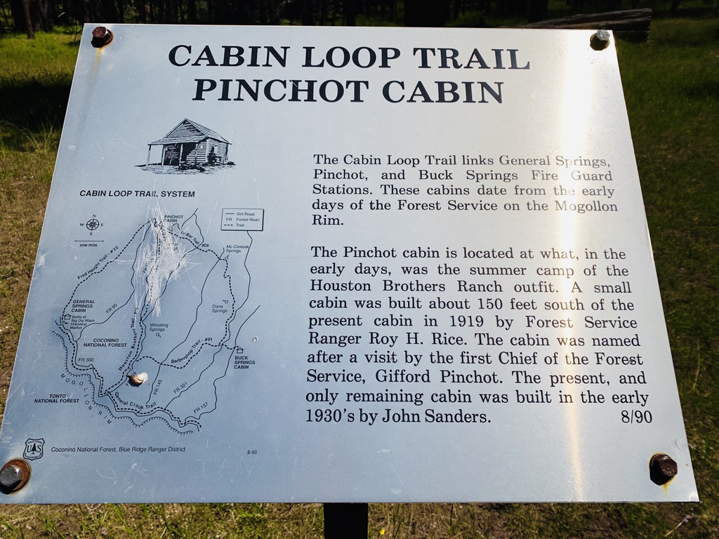
#7 Pinchot to General Springs Crew Zone (Mile 58.7) – 6.8 Mile Segment
Leaving Pinchot Cabin Aid Station you’ll cross the forest road leaving the station and almost immediately on the left is the start of the Fred Haught Trail. Pay attention here! Your left turn is almost immediately on your left, leaving the forest road for single track. The trail will take you down the trail ½ mile before hitting a forest road. This is a short stretch of road that takes you around Bear Canyon. This trail has been closed since 2017 when a flash flood destroyed the bridge on FS-95. The road is still closed but they've finally opened the trails up and you'll be some of the first to take this route...legally. You'll be dipping down into the canyon through piles of washed up logs and back up a short, steep slope to the road. Another easily missed turnoff here...not far after hitting the road, on the left you will see the turnoff for the single track of Fred Haught again (almost a 180 turn on the single track). If you walk across a cattle guard on the road you just missed it. Turn around and you’ll see it on the right headed up the hill.
There is a short but steep climb starting out again on the Fred Haught but aside from that there are some fun sections of ups and downs throughout this stretch. Again, there are more forest roads that access this area for various reasons and you will always see the trail on the other side of the road or fire break. This section is very well marked on its own with both Cabin Loop markers on the trees, Arizona Trail markers or signs of when you’ll hit it and “blazes” in the trees. Blazes are two chunks cut out of a ponderosa tree and then burned. They were done back in the 1800’s (some more recent) and signify the trail as well. These are all secondary markers to our orange/black polka dot (correct) and white/blue checkerboard (wrong way) markers but are reassuring nonetheless. Eventually the Fred Haught Trail meets back up with the Arizona Trail and the trail meanders along a river crossing it several times with some beautiful single track mixed with ferns all along the way. This terminates at the General Springs cabin and General Springs at a dirt road. You will have crew access here again and in about 1/2 a mile, you'll drop back off the Rim on your way to Washington Park and soon be cruising the Highline Trail more than halfway done.
General Springs Crew Zone is a good place for another pacer and has crew access, but no actual aid. Once you leave this area, you'll be below the Rim in Tonto National Forest land for the next 18 or so miles.
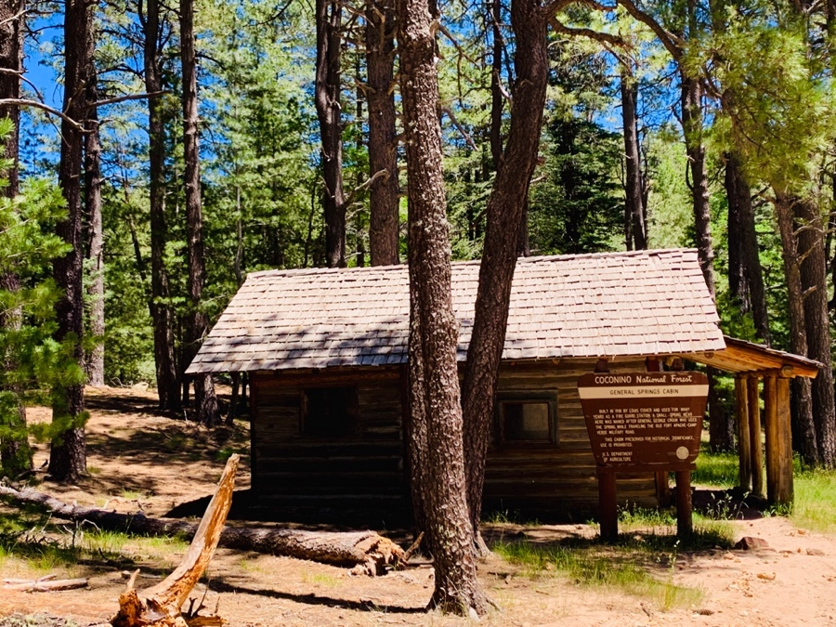
General Springs Cabin as you complete the Fred Haught Trail and head up the dirt road to the Rim Road
#8 – General Springs Crew Zone to Washington Park AS (Mile 61.1) – 2.4 Mile Segment
Continuing past General Springs, you run up the dirt road about 1/2 mile to the Rim Road and go straight across the road and follow the power line trail straight down the rim. The first 1/4 mile of this descent is nasty. Steep, with big loose rocks, and random little bushes and plants trying to gain a foothold in the 45-degree terrain. Take your time here and be glad you're not going up and down this stretch like in the past. Once you get through the initial sketch, the rest of the way is an easy trip to Washington Park on an old service road for the power line & newly designed single track to the aid station. The actual aid requires a tiny but super important out and back to the parking lot on your left.
What had always been the hub of The Monster, with runners hitting the Washington Park aid station three different times, WP is now a single stop at the 100Km mark. The next aid is 10 hardy miles away, so Washington Park is a good place to make sure you're ready to continue on in the last 1/3 of your race. Eat some real food, fill up your bottles and starting counting down those miles.
#9 Washington Park Aid to Geronimo AS (Mile 72.3) – 12.1 Mile Segment ~ 1,350 feet of Gain
This section is now 12.1 miles long as the Highline Restoration has now completed this stretch of trail. While the improvements have added mileage, the actual terrain is much improved and easier to run. Still, with 61+ Mogollon miles on your legs, this will likely take much longer as most will hit this section in the middle of the night. The Highline consists of lots of ups and downs, without a single long, sustained climb. You can follow Arizona Trail markers, Highline Trail #31 black diamond markers and the orange / black polka dot (good) and blue/white checkerboard (bad) we put out there.
#10 Geronimio Aid to Donahue AS (Mile 81.8) – 9.5 Mile Segment ~ 2,200 feet of Gain
From Geronimo Aid, you'll cross the dirt road and continue West on the Highline Trail continuing around the base of the Rim for just over 7 miles before turning right onto the Donahue Trail. This is a series of short switchbacks up the Rim with Manzanita and Cat Claw encroaching on the trail as you avoid the loose volcanic rocks that seem to radiate heat. Even better, you'll likely be able to catch views of the Town of Pine on this section, just a few miles away, but you still have 20+ miles and two climbs up the Rim to conquer (you're welcome). The climb up Donahue is short and punchy, climbing through loose volcanic rocks and manzanita up Donahue. You'll eventually pop out on a forest road and continue straight/bear left on the road for about 1 mile to the aid station. In the past, Donahue marked the 100 mile mark in the Monster, immediately after completing the brutal West Webber Climb but you're about to do a quick descent and your final rim climb leading to the next section.
NOTE: this section just feels long and can be quite warm as you hit it on Sunday morning, please make sure you have enough water and nutrition when leaving Geronimo.
#11 Donahue Aid to Dickerson Flat (NO AID) (Mile 85.6) - 3.9 Mile Segment ~ 1,800 feet of Gain
From the aid, you'll quickly begin your steep descent off the Rim, following a series of switchbacks through tall Ponderosa pines and eventually a couple of small streams with ferns aplenty. It's gorgeous in here. You'll come to the end of the West Webber Trail and turn left on Turkey Springs Trail where you'll climb slowly at first, but then be treated to more of those short switchbacks surrounded by manzanita, cat claw, loose rocks and dirt as you ascend to the top of the Mogollon Rim for a sixth and final time. You're not out of the woods yet, but you can certainly hold on to a bit of pride at the top here. Turn around and soak up this view, looking across the Rim in the direction you came from so many hours before.
#12 Dickerson Flat (NO AID) to Pine Canyon Aid (Mile 90.5) – 4.9 Mile Segment
This is another opportunity to chip away some miles without giving too much effort, assuming you're not totally spent from those brutal 86 miles that brought you here. But either way, the road is in decent shape, tucked in the Coconino National Forest and doesn't have a ton of traffic so you can relax the mind a bit as you make your way around Pine Canyon and eventually to the edge of the Rim one more time.
#13 Pine Canyon Aid to Pine Trailhead (Mile 101.1) – 10.9 Mile Segment
Shortly after leaving the aid station, you'll be treated to an exceptional view south into Pine Canyon. Soak. it. up. From here, you'll descend almost 1,800 feet in 2 miles on switchbacks and back into the forest. There is a small stream on your left that may just be worth the effort of leaving the trail for a dip in at this time. There are multiple trail signs on this section, none of them matching the other but expect 10+ miles of trail and know that even after dropping 1,800 feet, you'll continue to climb now and again on your way to the trailhead. This is a gorgeous trail, winding up, down, and around the canyon as you make your way closer and closer to the Pine Trailhead which will be just about 100 miles into the race. Ever run this far? Congrats! But you're not done. Grab some water for the victory lap and keep going.
#14 Pine Trailhead (Water Only) to Finish at the Town Ramada (Mile 102.6 ish) - 1.6 Mile Segment
This trailhead is less than 2 miles to the finish line. Pacers are welcome here to the finish. There’s no point in spending much time here unless you're in dire need of water. It’s a parking lot. It’s 2 miles from the finish.
Leaving Pine Trailhead AS you’ll run down the paved road for the trailhead to just before the 87 highway. To cross the road you’ll drop down 15 feet to the right to a culvert access point and go UNDER the road in the tunnel. This is the safest way to get across what can be a busy road. The tunnel is free of debris and about 30ft long. On the opposite side you will be directed 100 meters to the right to Bradshaw Road. Go left down the hill to Old County Road and go right. This is all paved now and the road goes through a residential street until it meets up again with the 87 right where the Old County Inn & our Friday packet pickup were. Head left along the wide shoulder into the town of Pine. You have about ½ a mile left and it’s all through the town itself. Follow the wide shoulder inside the white line past the Pinewood Tavern, Ponderosa Market, old buildings and the finish line will be at the Community Center just after JP's Place and by the ice cream shop on Randall.
You’ll see the finish line.
I recommend a full sprint to the finish.
