2025 Mogollon Monster 100 Mile Crew Manual

Anyone who has ever run an ultra, and more specifically a 100 miler, knows that the crew who follow their runner along all sorts of backwoods roads in areas with no cell service and unnamed junctions only to see their runner for 5-15 minutes between 3-4 hour gaps are the real MVPs. Seeing your smiling faces filled with encouragement, laughter and snacks each time they complete a section may be the only thing keeping them moving forward. So, thank you. Have fun while you’re in Rim Country and I hope you get to explore some of this beautiful area while assisting your runner.
This year’s running of the Mogollon Monster 100 course is the fifth year with the point-to-point route. With a number of restrictions on the bottom of the Rim, we have all available runner crew zones at aid stations above the Rim. We have three zones that are not aid stations where you are able to crew your runner in an effort to spread out crews and avoid crowding at the aid stations where parking is limited.

While the forest roads are in pretty good shape and can be traveled on with (mostly) any vehicle, the moving can be slow- especially on the windy Rim Road or FS-300. You wouldn’t need 4x4 to drive these roads but a high clearance vehicle certainly offers more peace of mind.
Weekend traffic sees a lot of OHV’s speeding around the area and there will certainly be wildlife moving around as well. Multiple times you will be driving on the same road as the runners so please go slow to keep our runners safe and avoid kicking up dust.
The Rim Road is incredibly scenic, you’re going to be impressed and you will probably stop to take at least a couple photos during your time up there (please do). But it also has a ton of hairpin turns and blind corners that include a 1,000+ foot drop ten feet beyond the edge of the road.

The most important thing with crewing on top of the Rim is that your vehicle never impedes the flow of traffic. If you cannot safely park in an area, please continue on or wait until a spot opens up. Our permitting agencies make this a huge sticking point each year and emergency vehicles (think, Firetrucks) need to be able to drive on all of these roads at all times (yes, even if you’re only going to be there for five minutes).
The second most important thing with crewing is if your runner decides to drop from the race, they absolutely, 100%, need to go to an aid station to report to race officials that they are no longer running in the race. THIS IS CRITICAL.

MedStar Solutions 24 Hr Emergency Number (also printed on runner bibs): 480-269-4126
Race Director, Noah Dougherty: 480-518-6731 (text or call)

You’ll also see three “Crews Only” zones on the 100 mile course. We implemented this to help spread out crews and also offer more locations to see your runner and vice versa. Some runners obviously won’t have crews and last year many of the crews were offering water, ice pops, snacks, etc. to anyone running by. It was very cool to see, and I know many runners were appreciative of this, even if they didn’t technically need anything at that time. We’d love to see a similar community feel return in 2025!

NOTE: Once you leave Pine or Payson and head to the top of the Mogollon Rim there will be no facilities. Please make sure you have everything you need for a full day (and night) on the rim if that is your plan. Your best bet for cell service is near the edge of the Rim. There are places otherwise, but this is your best chance at having a fair signal.

Food, Gas, and Supplies
Pine, AZ is a small town with just a few local restaurants and shops. They do have a small grocery store called the Ponderosa Market with most everything you need, including freaking delicious homemade pies, but no sports/endurance stores. There a couple gas stations in town including the Chevron on the northern end of town where they also sell pizza and other hot to-go items as well as a fair amount of camping equipment.
If you need any running gear last minute, your best bet is the Payson Walmart if you need more camping type supplies. If you are flying into Phoenix for the race there are a few ultrarunning stores called Sole Sports. www.solesportsrunning.com You can hit that up before heading up north if needed. They have anything ultrarunning related you may have forgotten.
There are several options for restaurants in Payson and a few in Pine:
Payson is larger and offers most fast-food options and some other dining options as well as hotels/motels, grocery stores, and gas stations.
Star Valley is a few miles east of Payson and also has a gas station right off the AZ260.
There is also a small general store in Forest Lakes & Rim Resort gas and supplies which are on the far eastern end of the Rim Road off of AZ260. You could hit one of these before going on the Rim Road towards crewing zones. It is near the Forest Lakes Lodge and includes two gas pumps, although their hours are limited.
Town of Pine Dining:
THAT Brewery is on the 87 right in Pine. They have beer and a full menu with proceeds going to the Arizona Trail and other local organizations. www.thatbrewery.com
The Old County Inn is new(er) place we are going back to this year that has a good patio, wood fired pizza, live music and solid beer options. http://www.oldcountyinn.com/
The Pinewood Tavern, located right next door to the town grocery market, is also owned by the same family as Old County Inn and offers a full bar and food menu.
Mike has also added a third restaurant to the mix with a killer deli & bottle shop just off the main drag called Pine Provisions.
For coffee and breakfast while your runner is off in the mountains running a ridiculous amount of miles in one go, they have Early Bird Café for traditional diner food that’s right next to our finish line on the main road in town. There’s also a great little fudge, ice cream and espresso shop just north of the Old County Inn on the opposite side of the road called the Pine Creek Fudge & Espresso.

Closer to the 100 mile start line, Christopher Creek offers a couple dining options including the Landmark at the Creek with a great patio area in the trees and the Creekside Tavern.

-----------------------------------------------
Below you will find directions to each aid station that will be used in 2025. These directions were pulled using Google Maps.
NOTE: By clicking the name of the aid station or scanning the QR Code, you will get a google pin drop to the aid. Some of the info is simply a Google Pin drop that you can scan and get directions from your location. Some of the QR Codes are actual directions from one aid to the next. Please ensure you have Google Maps BEFORE arriving on the Rim as service will be spotty.
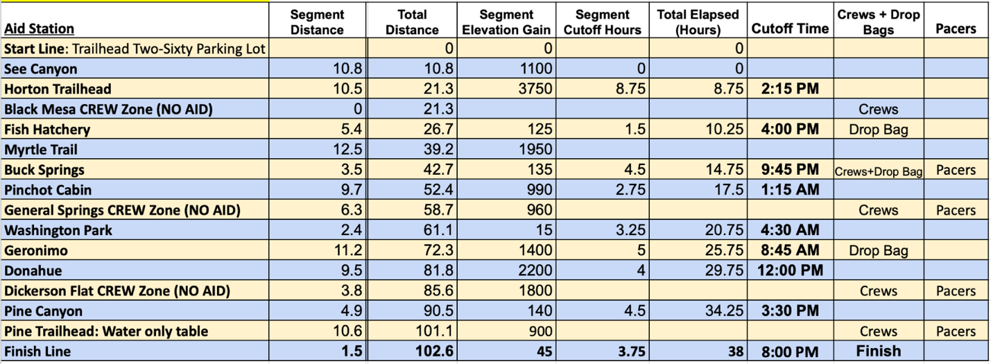

Packet Pickup Location – Friday, September 5, 2025, 4-7 p.m.
Old County Inn – 3502 AZ-87. Pine, Arizona 85544
You will see us setup in the parking lot. Come hang out and grab some food and a pre-race beverage. All participants will receive a ½ off pint ticket that is good at this location or the Pinewood Tavern in town all weekend!
---------------------------------------------------------------
Runner/Crew Event Parking for Start –
Old Pine Parking Area
This parking area is much larger than the Pine Trailhead and also allows free, dispersed camping all weekend. We will be shuttling runners from here on race morning to two different locations based on their distance. Vehicles may be left here all weekend.
Runners may get dropped off at their respective start line but you cannot park there or leave a vehicle at the start.
100 Mile Start Line: Trailhead Two-Sixty.
42KM (Sunday) Start Line: Pine Trailhead.
---------------------------------------------------------------------
Finish Line – Pine Town Community Center
The finish line for both distances is at the Pine Town Ramada which is in the center of Pine on the main road. There is parking surrounding the area as well as a couple food options within walking distance. There’s a small playground for kids as well. We are right next to the Pine- Strawberry Museum which is typically open and either costs $1-$2 as a donation or free.
NOTE: We do not have a formal shuttle that is dedicated to bringing runners back to their vehicle if it is parked at the Old Pine Parking area or Pine Trailhead but have a truck to get them a ride back to their vehicle as quickly as possible.
-----------------------------------------------------------------------------
 Two-Sixty Trailhead – 100 Mile Start Line

From Payson, you take the AZ-260 East about 24 miles to the short road leading up the hill to the trailhead. On race morning we will have the outside lane open specifically for our busses and crews dropping off their runners. This is about 45 minutes from Pine.

 Pine Trailhead – 42 Km Start line
This trailhead is less than one mile from the actual Town of Pine and has a large brown recreation sign stating Pine Trailhead. There is no extended parking here, however you may drop off your runner here or 100 mile crews can have a pacer join them from here to the finish (just under 2 miles).

BOTTOM OF THE RIM AID STATIONS
These directions are being supplied for the purpose of dropping off and/or picking up a volunteer, runner drop, or staff person. There is NO crewing, spectating, or pacing allowed at ANY of the aid stations below the rim.
TOP OF THE RIM AID STATION DIRECTIONS
 Black Mesa Crews Only Zone (Google Pin Drop) – This is a crew only area, spanning over about 3 miles of the 100 mile course on the Rim Road between Horton Creek Trail & Babe Haught Trail. Please only stop in pull-off areas and not on the actual Rim Road/FS-300 where other vehicles must actively go around you. Offer hydration/nutrition to runners without crews if you can!
NOTE: The Horton Aid Station is located just east of this crew zone but there is NO parking at the aid and no crews allowed AT the aid station.
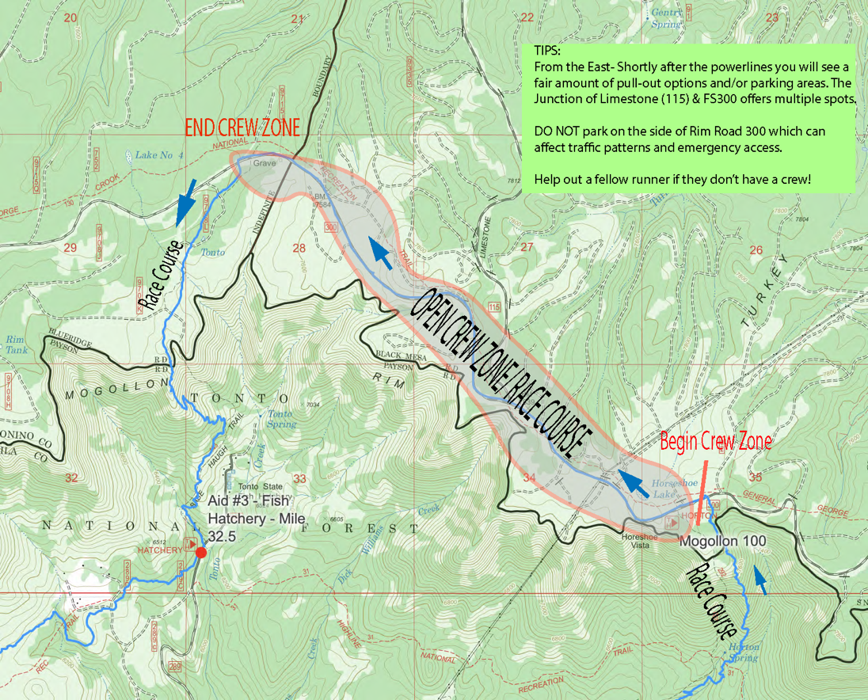
--------------------------------------------------------------------------------------
 Buck Springs Aid Station (Google Pin Drop) – Crew Access Allowed – This aid station is located just over 3.5 miles from Myrtle Aid Station. Turn onto FS321 and continue for just over 3 miles to Buck Springs Aid Station which will be on your right.
NOTE: Runners will be on the Rim Road & FS321 the entire way so please drive slowly and be aware!
Cell Service: There is no cell service at Buck Springs. If you are able to wait in a pull off on the FS300/Rim Road that may be best so you can check our timing for when your runner hits Myrtle Aid or even Fish Hatchery below the Rim.
-------------------------------------------------------------------------

 General Springs Crews Only (NO AID) (Pin Drop) ~
From Pine: 32.5 Miles/ 1 Hr 16 Minutes
Runner Mile: 62.2
crews and pacers, no drop bags and no aid station

From the Pine Trailhead, head north on AZ-87 for 14.5 miles to the turnoff for the FS-300 or Rim Road. Follow the signs left for the Rim Road once you’ve made the right turn off the 87 and continue on the Rim Road for 12 miles to the powerlines where the trail crosses and turn left down the hill on FS-393 to the General Springs Cabin.
NOTE: At this turn, runners will be on the road! Please use caution here. Really, use caution throughout this drive as it contains many hairpin turns on blind corners and washboards. And incredible views. This area is around 1/3 mile and runners will run the length of the road, popping out near the actual cabin and heading up the road to the Rim Road and dropping off a cliff. So, don’t worry too much as to what spot you get – just as long as it doesn’t impede traffic or destroy the plants and bushes off the road either.
Cell Service: Again, there is likely no cell service at the cabin where parking is. Consider finding a spot off the Rim Road where you are in cell service to wait until your runner is expected to be approaching.
---------------------------------------------------------------------------

 Dickerson Flat Crews Only Area- NO AID (Google Pin Drop to Turkey Springs junction with Road)
This crew zone is located on Milk Ranch Point Road. When you turn off of AZ-87 for Rim Road/FS-300, continue straight. Do NOT take the Rim Road left. After about 1.2 miles you’ll come to a Y in the road, remain right, and continue another 1.7 miles to the Turkey Springs Trailhead on your left and a large meadow on your right with pull off areas for dispersed camping. There are a fair amount of pull off areas for parking right near this junction from Turkey Springs Trail and the road. You need to crew in the immediate area near the Turkey Springs Trailhead and not throughout the entire road section here. DO NOT block the roadway at all! NOTE: There will be runners on the road the entire way to the aid station.
Cell Service: There is no cell service in this area of the course so consider timing your arrival with that in mind.

