2021 Mogollon Monster 100 Crew Manual

This year’s running of the Mogollon Monster 100 course is entirely new in its point-to-point nature. However, many of the same trails and aid stations are still in use.

While the forest roads are in pretty good shape and can be traveled on with (mostly) any vehicle, the moving can be slow- especially on the windy Rim Road or FS-300. Weekend traffic sees a lot of OHV’s speeding around the area and there will certainly be wildlife moving around as well. Multiple times you will be driving on the same road as the runners so please go slow to keep our runners safe and avoid kicking up dust.
The Rim Road is incredibly scenic, you’re going to be impressed and you will probably stop to take at least one photo during your time up there. But it also has a ton of hairpin turns and blind corners that include a 1,000+ foot drop ten feet beyond the edge of the road.

NOTE: Once you leave Pine or Payson and head to the top of the Mogollon Rim there will be no facilities. Please make sure you have everything you need for a full day (and night) on the rim if that is your plan. Your best bet for cell service is near the edge of the Rim. There are places otherwise, but this is your best chance at having a fair signal.

Below you will find directions to each aid station that will be used in 2021. These directions were pulled from Google Maps.
NOTE: By clicking the name of the aid station or scanning the QR Code, you will get a google pin drop to the aid. Please ensure you have Google Maps BEFORE arriving on the Rim as service will be spotty.

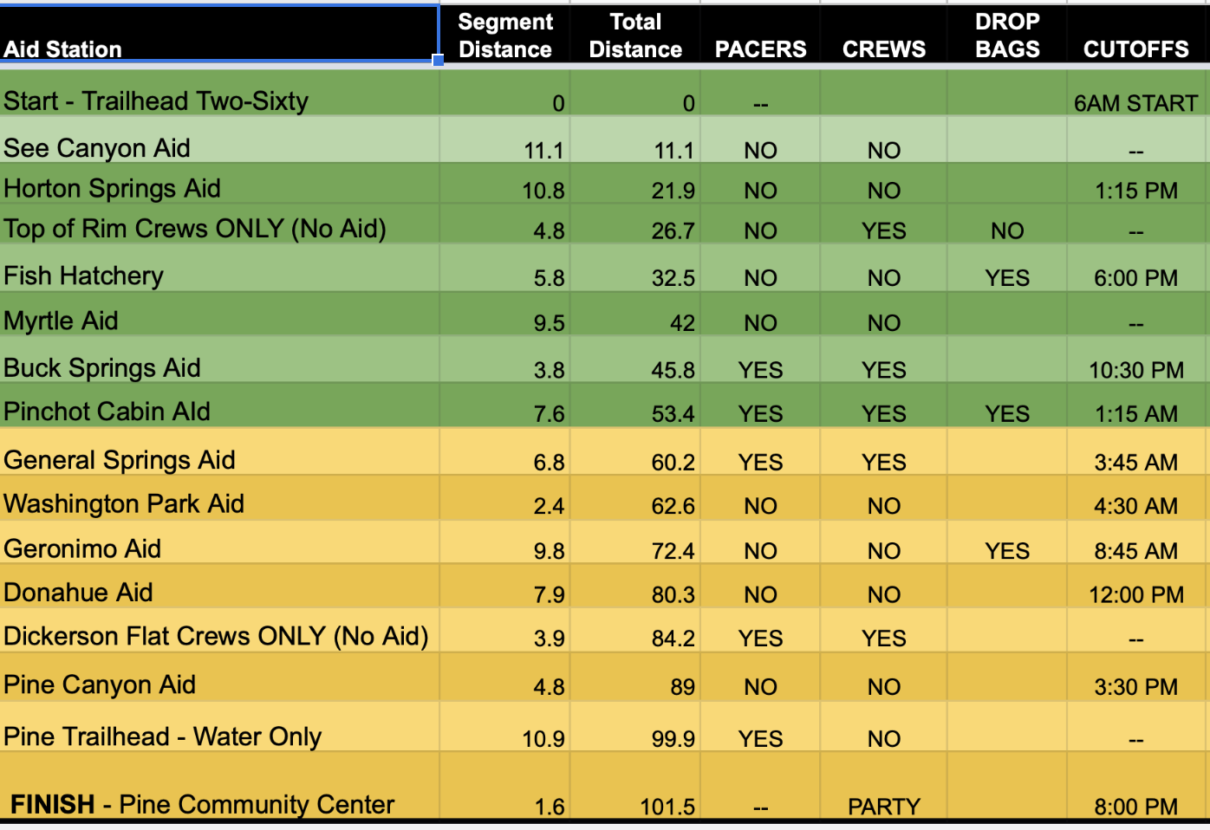
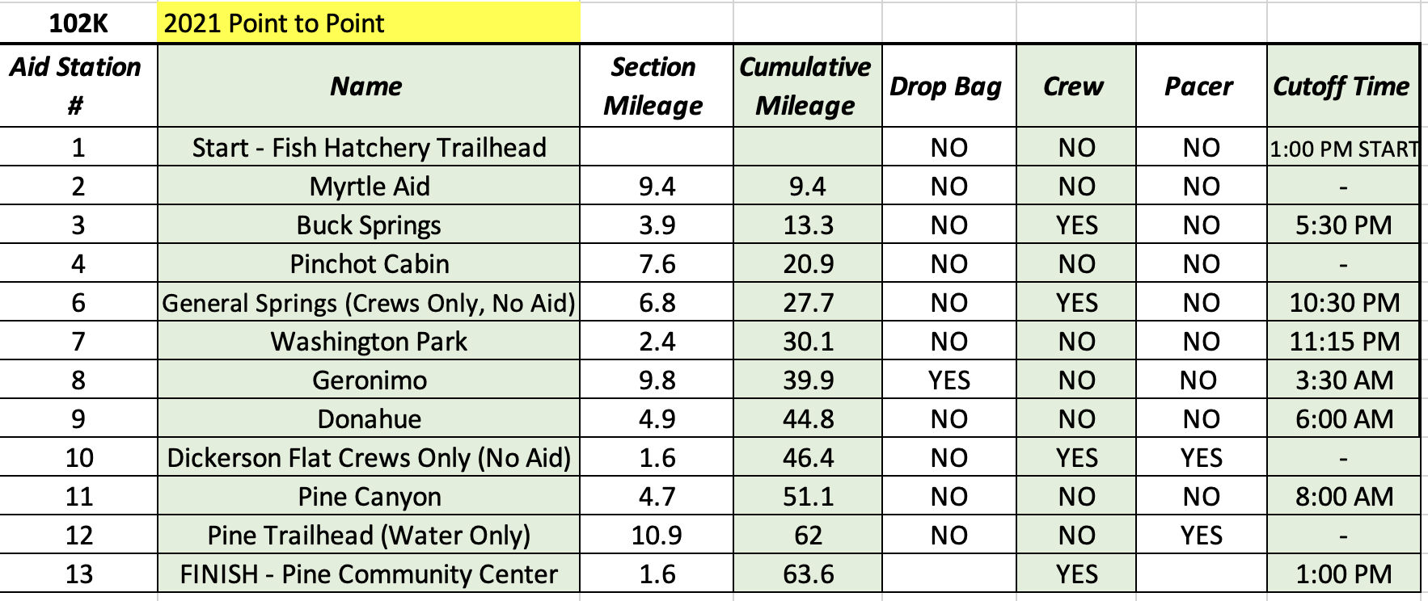
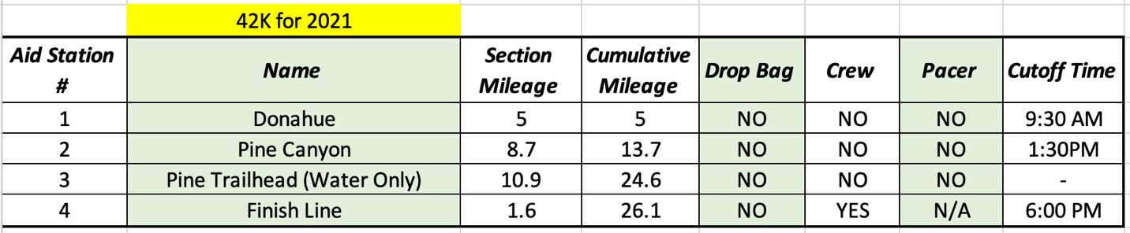
Packet Pickup Location – Friday, September 10, 2021 4-7 p.m.
Old County Inn – 3502 AZ-87. Pine, Arizona 85544
You will see us setup in the parking lot. Come hang out and grab some food and a pre-race beer. All participants will receive a ½ off pint ticket that is good at this location or the Pinewood Tavern in town all weekend!
---------------------------------------------------------------
Runner/Crew Event Parking for Start – Old Pine Parking Area
This parking area is much larger than the Pine Trailhead and also allows dispersed camping all weekend. We will be shuttling runners from here on race morning to two different locations based on their distance. Vehicles may be left here all weekend.
100 Mile: Trailhead Two-Sixty.
105KM: Fish Hatchery.
40KM (Sunday): Pine Trailhead.
---------------------------------------------------------------------
Finish Line – Pine Town Ramada
The finish line for all three distances is at the Pine Town Ramada which is in the center of Pine on the main road. There is parking surrounding the area as well as a couple food options within walking distance. There’s a small playground for kids as well. We are right next to the Pine- Strawberry Museum which is typically open and either costs $1-$2 as a donation or free.
NOTE: We do not have a formal shuttle that is dedicated to bringing runners back to their vehicle if it is parked at the Old Pine Parking area or Pine Trailhead but do our best to get them a ride back to their vehicle as quickly as possible.
-----------------------------------------------------------------------------
Two-Sixty Trailhead – 100 Mile Start Line

From Payson, you take the AZ-260 East about 24 miles to the short road leading up the hill to the trailhead. On race morning we will have the outside lane open specifically for our busses and crews dropping off their runners. Crews/volunteers will have a few spaces in the center of the lot where they can park leading up to the start. This is about 45 minutes from Pine.

BOTTOM OF THE RIM AID STATIONS

These directions are being supplied for the purpose of dropping off and/or picking up a volunteer, runner drop, or staff person. There is NO crewing, spectating, or pacing allowed at ANY of the aid stations below the rim.
TOP OF THE RIM AID STATION DIRECTIONS
Black Mesa Crews Only Zone (Google Pin Drop) – This is a crews only area that we have added, spanning over about 3 miles of the 100 mile course on the Rim Road between Horton Creek Trail & Babe Haught Trail. Please only stop in pull-off areas and not on the actual Rim Road/FS-300 where other vehicles have to actively go around you. Offer hydration/nutrition to runners without crews if you can! 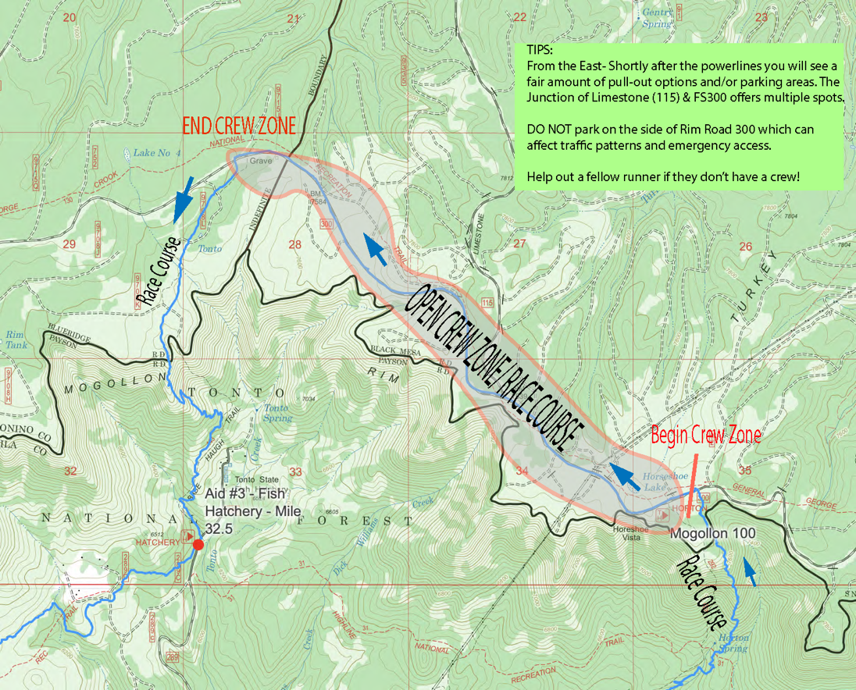

Buck Springs Aid Station (Google Pin Drop) – Crew Access Allowed – This aid station is located just over 3.5 miles from Myrtle Aid Station. Turn onto FS321 and continue for just over 3 miles to Buck Springs Aid Station which will be on your right.
NOTE: Runners will be on the Rim Road & FS321 the entire way so please drive slowly and be aware!
-------------------------------------------------------------------------
Pinchot Cabin Aid Station (Google Pin Drop)
This aid station is located about ¼ mile onto the 139A from FS-95.
MORE ON PINCHOT AID STATION BELOW
Buck Springs AS to Pinchot Cabin AS (13.7 miles/ 33 Minutes)
100M Runners completed mileage: 50.5
Pacer Access: YES
Crew Access: YES

Continue north on FS-321 for 6.6 miles where you’ll come to a “Y” in the road. Continue left on FS-96 for two miles where you’ll essentially dead end at the FS-95 where you’ll head left, doing a 180 and heading in the direction towards the edge of the Mogollon Rim. Follow this road about 4.5 miles where you’ll dip down into a small canyon and see a parking area on your right. From here you can cut through the open area (on your left) until you intersect the race course and head right, up the hill to the aid. Otherwise, you can walk up the hill for about ½ mile on the road until you see the left turn for the FS139a (the only road you can turn left) and the aid station is a quarter mile from there.
There is very limited parking near the aid station but it’s possible that you will get up there and have to turn around and drive back down to the parking area mentioned above. Your call. If there is no space in the parking lot and requires you park off the side of the road, leaving plenty of space for emergency vehicles to get through. You cannot park your vehicle on FS-95 roadway! And only park on ONE side of the road. 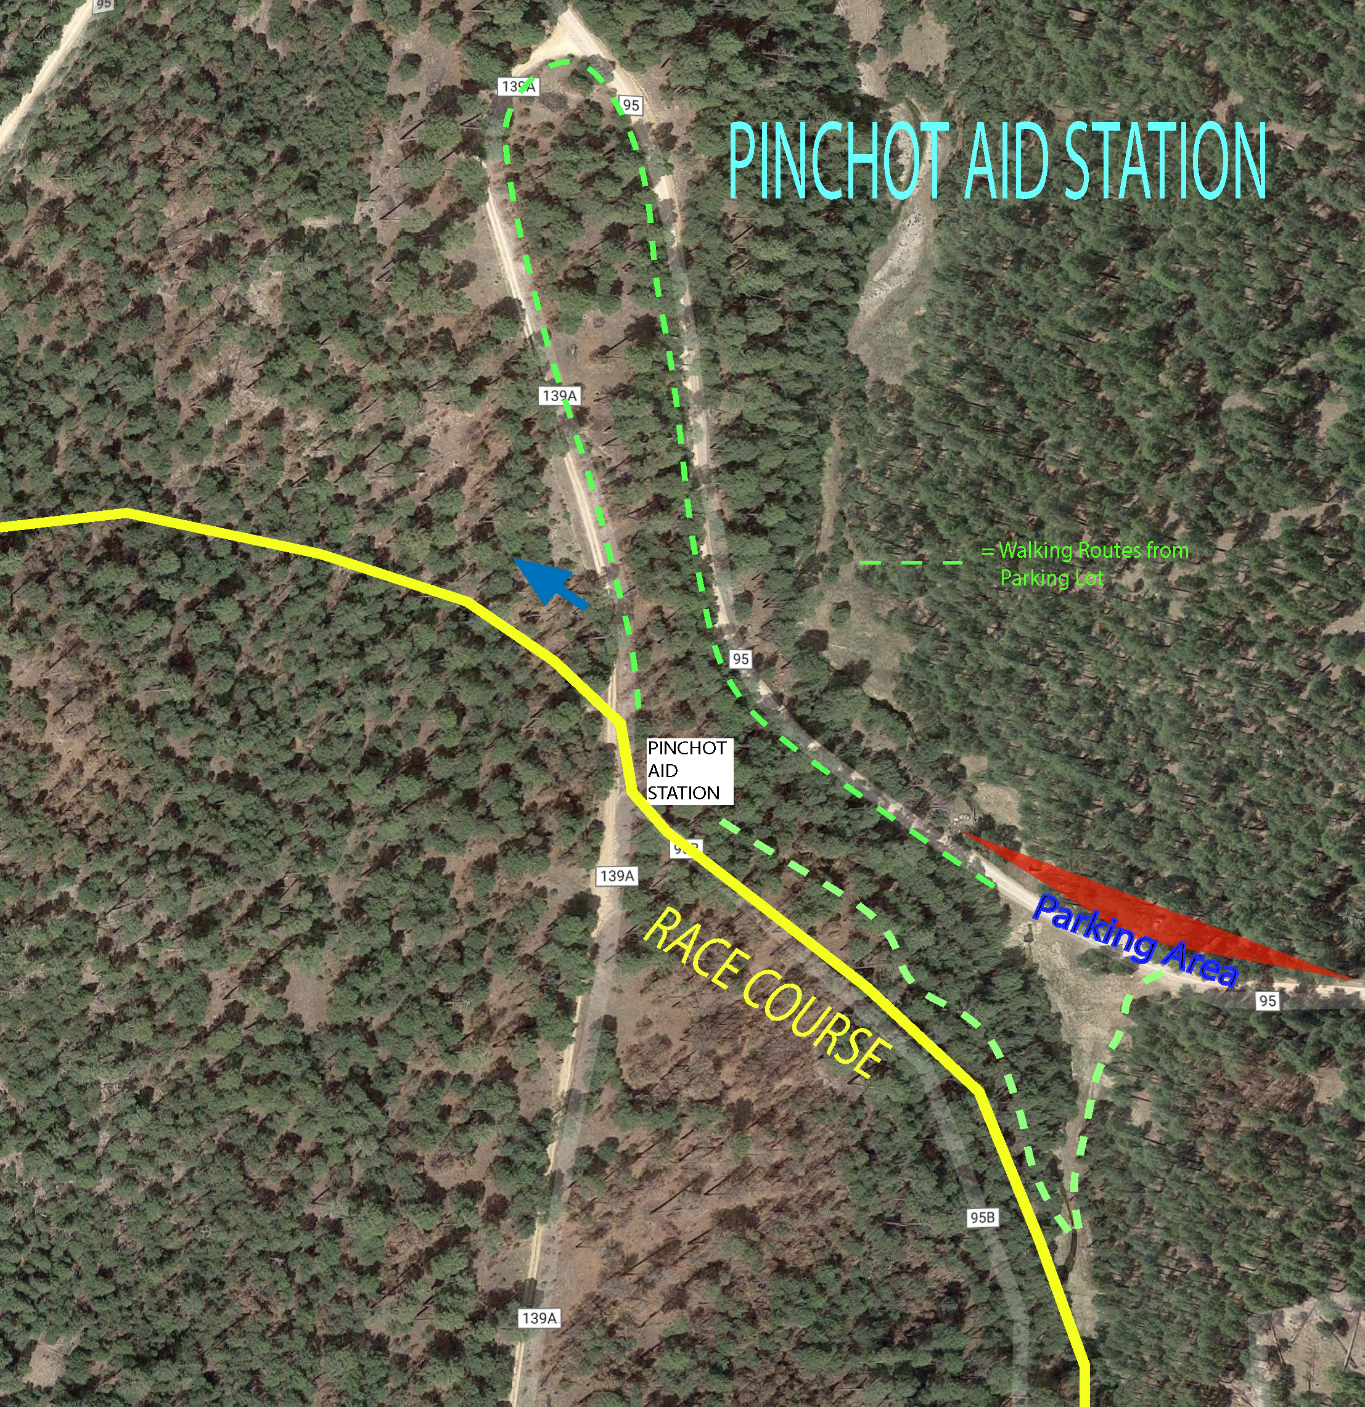

General Springs Crews Only (No Aid) (Pin Drop) ~
From Pine: 32.5 Miles/ 1 Hr 16 Minutes
Runner Mile: 62.2
crews and pacers, no drop bags

From the Pine Trailhead, head north on AZ-87 for 14.5 miles to the turnoff for the FS-300 or Rim Road. Follow the signs left for the Rim Road once you’ve made the right turn off the 87 and continue on the Rim Road for 12 miles to the powerlines where the trail crosses and turn left down the hill on FS-393 to the General Springs Cabin.
NOTE: At this turn, runners will be on the road! Please use caution here. Really, use caution throughout this drive as it contains many hairpin turns on blind corners and washboards. And incredible views.
---------------------------------------------------------------------------

Dickerson Flat Crews ONLY Area (Google Pin Drop to Turkey Springs junction with Road)
This crew zone is located on Milk Ranch Point Road. When you turn off of AZ-87 for Rim Road/FS-300, continue straight. Do NOT take the Rim Road left. After about 1.2 miles you’ll come to a Y in the road, remain right, and continue another 1.7 miles to the West Webber Trailhead on your left. There are a fair amount of pull off areas for parking right near this junction from Turkey Springs Trail and the road. You need to crew in the immediate area near the Turkey Springs Trailhead and not throughout the entire road section here. DO NOT block the roadway at all!
NOTE: There will be runners on the road the entire way to the aid station.

